Software Requirement Specification Document

For

Simple Password Generator and Tracker

Table of Contents
Page Numbers
- Introduction---------------------------------------------------------------------------------------------------------- 3-4
  - Purpose------------------------------------------------------------------------------------------------------ 3
  - Intended Customers/Users------------------------------------------------------------------------------- 3
  - Product Scope----------------------------------------------------------------------------------------------- 3
  - Outline of the document -------------------------------------------------------------------------------4
- Overall Description--------------------------------------------------------------------------------------------------5-8
  - Product Perspective---------------------------------------------------------------------------------------- 5
  - Product Functions------------------------------------------------------------------------------------------ 6
  - User Classes--------------------------------------------------------------------------------------------------7
  - Design and Implementation Constraints--------------------------------------------------------------8
- Diagrams------------------------------------------------------------------------------------------------------------- 9-13
  - UML Diagrams------------------------------------------------------------------------------------------------9
  - ER Diagrams--------------------------------------------------------------------------------------------------10
  - DFD Diagrams------------------------------------------------------------------------------------------------11
  - Assumptions and Dependencies------------------------------------------------------------------------13
- External Interface Requirements/Screenshots---------------------------------------------------------------14-15
  - User Interfaces-----------------------------------------------------------------------------------------------14
  - Hardware Interfaces----------------------------------------------------------------------------------------15
  - Software Interfaces-----------------------------------------------------------------------------------------15
  - Communication Interfaces--------------------------------------------------------------------------------15
- Other Non-Functional Requirements
  - Performance Requirements
  - Safety Requirements
  - Security Requirements
  - Software Quality Attributes
  - Business Policies/Rules (if any)
- Testing
  - White-Box Testing------------------------------------------------------------------------------------------16
  - Black-Box Testing-------------------------------------------------------------------------------------------19
- Conclusion
- References
- Acknowledgements------------------------------------------------------------------------------------------------- 27

- INTRODCUTION

The Password Generator and Manager is designed to ease the everyday burden of dealing with many passwords for different websites and apps. It offers a single, well‑organized space where users can generate trustworthy passwords, save all their credentials, and regularly check how safe those credentials are. At the same time, it aims to remain simple and comfortable to use, so that even people with limited technical knowledge can naturally build stronger and more disciplined password habits.

  - Purpose

The main purpose of the Password Generator and Manager is to give users a safe, intuitive way to manage all their passwords in one centralized application. It removes the pressure of remembering complex passwords or reusing the same weak password everywhere by helping users create stronger alternatives and keeping them securely stored for later use. The application also encourages better security behavior by checking whether passwords are commonly used, showing how strong they are, warning about reused or outdated passwords, and protecting stored data with a PIN or master password, two‑factor authentication, and automatic data wipe after too many failed attempts.

  - Intended Customers and Users

The primary users of this application are people who handle multiple online and application accounts and want a secure yet straightforward way to generate, save, and retrieve strong passwords without depending on memory or scattered notes. A secondary audience includes teachers, project guides, examiners, and student developers who may use this system as a practical example or project, helping them explore areas such as secure software design, information protection, and the creation of clear, user‑friendly interfaces.

  - Product Scope

This product will enable users to generate several strong password options for each account, tailored to their preferences for length and character composition and to the specific rules of a site or application, while comparing each suggestion against a catalogue of commonly used or compromised passwords and presenting a clear strength indicator with constructive guidance for improvement. It will store details such as the name and type of the service, username or email address, password, notes, and an appropriate category or security level inside an encrypted vault that can be opened only after successful authentication with a master PIN or master password, with optional two‑factor verification and additional safeguards such as automatic clearing of the clipboard after a password is copied. It will further provide practical, user‑friendly features including full‑text search across all saved entries, swift access to view or copy passwords, structured organization by categories and security levels, a dedicated security‑audit view that highlights weak, reused, or outdated passwords, an optional decoy vault for plausible deniability, and an automatic data‑wipe mechanism that erases all stored information after a defined number of failed login attempts, accompanied by clear warnings during the final attempts.

  - Outline of the Document

Section 1 presents an overview of the Password Generator and Manager, explains the motivation for developing the system, identifies the intended users, states the rationale for this SRS, and delineates the overall scope of the product. The subsequent sections will describe the overall system context, detailed functional requirements, user classifications, design and implementation constraints, diagrams and models, external interface requirements, non‑functional requirements such as performance, reliability, safety, and security, the planned testing strategy, and finally the references and acknowledgements, following a recognized and systematic SRS structure.

- OVERALL DESCRIPTION

The Password Generator and Manager is a standalone application that acts as a personal password vault and a quiet security companion for the user. It helps people create strong and trustworthy passwords, store credentials for both websites and applications, and retrieve them within seconds, while every sensitive detail remains encrypted and protected by a master PIN or master password. The system is meant to run on a single device and to work comfortably even without a constant internet connection, so that control over confidential information stays firmly in the user’s hands.

The application uses simple and clear screens that are easy for users to move through one step at a time. There are separate views for logging in, creating new passwords, browsing all saved accounts, opening a single entry and checking how strong the stored passwords are overall. All private information is handled with care and is only shown or shared when the user clearly chooses that option. The main aim is to make strong security feel like a normal part of daily life so that people gradually build better password habits and feel safe trusting the app with their online accounts.

  - Product Perspective

This application is a fresh and self‑contained product, not an attachment to any existing institutional system. It behaves like a dedicated personal vault that the user installs on a chosen device in order to manage private credentials for websites and applications. When it occasionally interacts with external services, for example to send a one‑time code for additional verification or to refresh a list of common passwords, these actions are treated as helpful refinements rather than strict requirements for the main behavior of the vault.

From the user’s point of view, the application is formed from several closely linked parts that operate together as a single, coherent system:

- A secure login and recovery component that checks the master PIN or master password, performs any extra verification steps, and applies rules for failed attempts and automatic erasure of stored data.

- A password‑vault component that encrypts, stores, and retrieves credential records, including names of sites and applications, usernames or email addresses, passwords, notes, and categories or security levels.

- A password‑generation and evaluation component that creates suggestions, compares them with known weak or compromised passwords, and presents a clear strength indicator with concise guidance for improvement.

- A search and navigation component that enables users to browse, filter, and locate stored credentials quickly, then open any record to view, revise, or copy its details.

The application assumes that the operating system offers dependable basic services like saving files, showing buttons and screens, and keeping encryption keys safe. Having an internet connection can make the experience better, but it is not required, because important tasks such as creating, saving, and viewing passwords still work even when the device is offline.

  - Product Functions

The main functions of the Password Generator and Manager describe how the application should behave from the user’s perspective and what it is expected to accomplish in everyday use.

  - User authentication and access control
  - Allow the user to create a master PIN or master password during the first‑time setup of the application.
  - Request this master credential every time the application is opened and, when enabled, ask for an additional verification step such as a one‑time code.
  - Count unsuccessful login attempts, show clear warnings as the limit is approached, and erase all stored data once the permitted number of consecutive failures has been exceeded.
  - Password generation and evaluation
  - Provide several password suggestions for each account, shaped by the user’s preferences for length and character variety, while avoiding confusing characters when desired.
  - Respect the specific password rules of each website or application so that generated passwords satisfy length and character requirements without further adjustment.
  - Compare every generated or manually entered password with a curated list of common or compromised passwords and reject those that are considered unsafe.
  - Display a clear strength indicator for each password, together with short, practical explanations and advice on how to make it more resilient.
  - Credential storage and management
  - Allow the user to create, update, and remove records that contain the name of the site or application, the type of service, the username or email address, the password, relevant notes, and a suitable category or security level.
  - Encrypt and store all credential information in a secure vault file or database that cannot be understood without the correct master credential.
  - Provide a safe way to copy passwords to the clipboard and automatically clear the clipboard after a brief interval, reducing the risk of accidental exposure.
  - Search, organization, and quick access
  - Show a structured list of all stored credentials after the user has logged in, with options to sort or filter entries by name, category, or security level.
  - Offer a search field that narrows the list in real time as the user types part of the site name, application name, username, or tag, making it effortless to locate a particular entry.
  - Open a detailed view for any selected record in which the user can reveal or copy the password and refine the stored information.
  - Security audit and user guidance
  - Examine stored credentials on request, or at suitable intervals, to identify passwords that are weak, reused, or very old, and present them in a dedicated security‑audit view.
  - Allow users to regenerate and update unsafe passwords directly from this audit screen by opening the generator with that account already selected, making corrections swift and straightforward.
  - Offer an optional decoy vault that can be unlocked with an alternative master credential and that contains harmless sample data for situations in which the user might be pressured to reveal the application.

Taken together, these functions ensure that the application does far more than simply store passwords. It actively supports the user in building stronger and more disciplined password practices while keeping everyday tasks, such as finding, updating, and using credentials, straightforward and efficient.

  - User Classes

The application is intended for a small number of clearly defined user groups, which helps keep the design focused and intuitive.

- Regular users
These are everyday users who want a safe and convenient place to store their passwords. They may have only basic technical knowledge and therefore expect clear screens, simple language, and minimal configuration. Their usual activities include generating passwords, saving credentials, searching for entries, and copying passwords when needed.

- Power users
These users are more comfortable with technology and pay closer attention to security. They are likely to use advanced options such as categories, security levels, detailed password‑strength information, and the security‑audit view, and they may adjust settings like clipboard‑clear time or the number of allowed failed login attempts.

- Academic users and developers
This group includes teachers, project guides, examiners and student programmers who use the application as a practical example or as a base for new ideas. They focus on how well the system meets its security and usability goals and on how its design can be improved, extended or carefully studied in later versions.

2.4 Design and Implementation Constraints

The Password Generator and Manager must be designed with a few practical boundaries in mind so that it stays secure, pleasant to use, and realistic for everyday devices. These constraints shape the technical choices behind the application and help maintain a sensible balance between strong protection, good performance, and a clear, understandable experience for the user.

- Security standards
The application must rely on strong and widely accepted encryption methods for storing passwords and other sensitive data. All encryption and decryption should take place on the user’s device so that confidential information is not exposed to external servers without explicit consent.

- Platform limitations
The app should run smoothly on everyday laptops and phones, not only on very powerful devices. When it is busy in the background, for example while checking many saved passwords, it should still react quickly to touches and clicks and clearly show that it is working so the user does not think it has stopped or crashed.

- Usability and clarity
The screens should look clean and simply and show only the buttons and options the user actually needs. When an action might remove data, such as deleting a saved account or clearing the whole vault, the app should clearly say what will happen and ask the user to confirm so nothing important is lost by accident.

- Offline‑first behavior
Essential capabilities such as viewing, adding, editing, and generating passwords must work without an internet connection. Online features, including updating lists of common passwords or sending verification codes, should be treated as helpful additions rather than strict requirements.

- DIAGRAMS

This section gives a high-level view of how the main parts of the Password Generator and Manager interact with each other and with the user. The diagrams are meant to support understanding; they do not describe every detail of the design but show the main structure and data flow of the system.

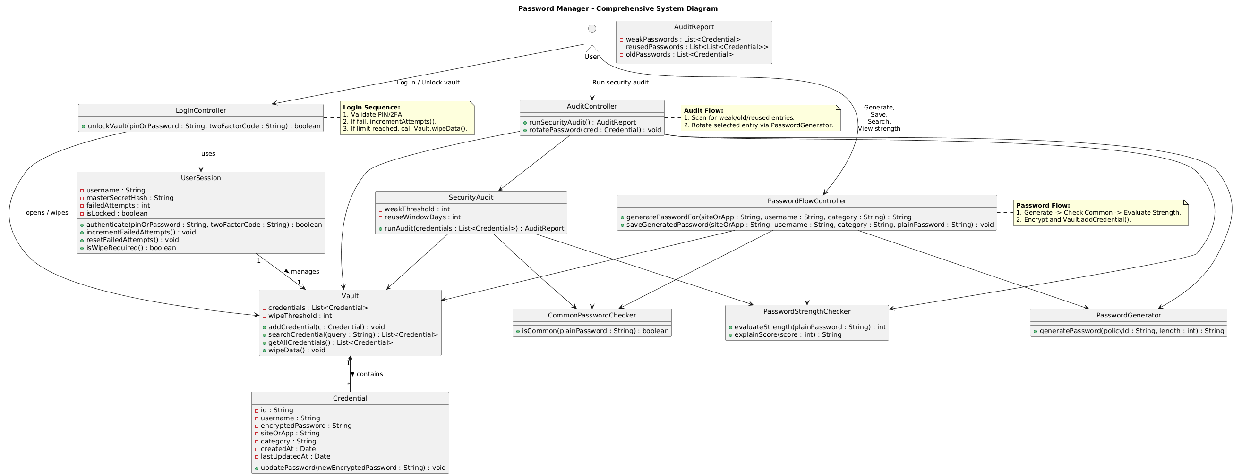

  - UML Diagram

For this project, the UML diagrams will focus on the core behaviour of the app: how the user logs in, how passwords are generated and stored, and how entries are searched and audited.

- The use case diagram will show the main actions of the user, such as “Log in”, “Generate password”, “Save credentials”, “Search credentials”, “View password strength” and “Run security audit”.

- The class diagram will present key classes like UserSession, Vault, Credential, PasswordGenerator, PasswordStrengthChecker, CommonPasswordChecker, and SecurityAudit, along with important attributes such as username, encryptedPassword, category, and methods like generatePassword(), evaluateStrength(), addCredential(), searchCredential(), and wipeData().

- The sequence diagrams will describe important flows:
  - Unlocking the vault with master PIN or password (and optional two-factor code), including counting failed attempts and performing a data wipe after the limit.
  - Generating a password for a site or app, checking it against rules and common-password lists, displaying strength, and then saving it as a new credential.
  - Running a security audit to detect weak, reused or old passwords and then updating a selected entry with a newly generated password.

These UML diagrams together should give a clear picture of how data moves through the system and how the main components cooperate whenever the user performs a task.

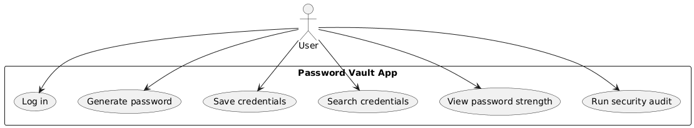

  - ER Diagram

The Entity–Relationship (ER) diagram will describe how data is stored in the vault. It will mainly focus on the tables or collections used in the local database.

Typical entities will include:

- User – stores information about the master account, such as userId and fields needed for authentication and optional recovery.
- Credential – stores one record per saved site or app, including credentialId, name, type (site or app), usernameOrEmail, encryptedPassword, notes, category, securityLevel and timestamps like createdOn and lastUpdatedOn.
- SecuritySettings – keeps user preferences such as maximum failed attempts before data wipe, clipboard-clear time and whether the decoy vault is enabled.
- AuditLog – optionally records important events such as login attempts, vault unlocks, and data-wipe actions, without storing actual passwords.

Relationships will show that one User owns many Credential records and one set of SecuritySettings, and that many AuditLog entries can be linked back to one User. This diagram helps clarify how information is organised and how tables are connected inside the application’s database.
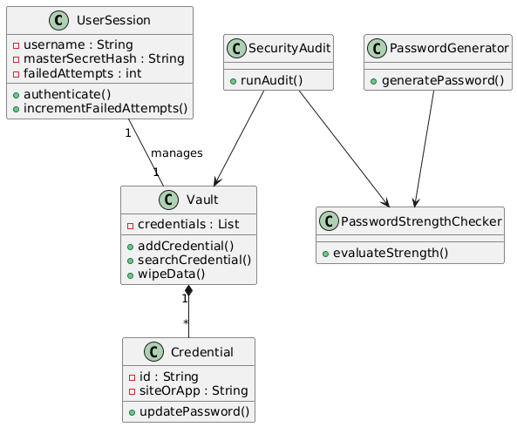

  - DFD Diagram (State Diagram)

The Data Flow Diagrams (DFDs) will show how information moves between the user, the application processes and the data stores.

- The Level-0 DFD will depict the system as a single process “Password Generator and Manager” with the user as the main external entity. Data flows will include actions such as login details, generated passwords, credentials, and feedback messages.
- The Level-1 DFD will break the main process into sub-processes such as “Authenticate User”, “Manage Vault”, “Generate and Evaluate Password”, “Search Credentials” and “Run Security Audit”. The main data stores will be the encrypted vault (credentials), settings, common-password list and optional audit log.
- Each sub-process can be refined further if needed. For example, “Authenticate User” can be split into “Verify Master Credential”, “Apply Two-Factor Check” and “Handle Failed Attempts and Wipe Data”.

These DFDs will make it easier to see where data is created, transformed and stored, and will help in validating that all important flows—such as login, password generation, saving, search and auditing—are covered correctly in the design.

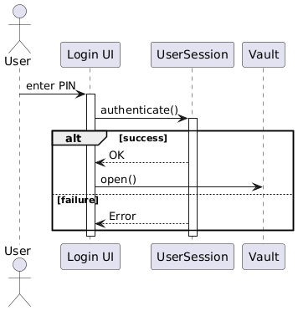

  - Assumptions and Dependencies

This section outlines the key environmental expectations and technical essentials needed for the Password Generator and Manager to work smoothly.

Assumptions
Users have modern devices (laptops or smartphones) with basic services like file storage, clipboard access, and familiar graphical interfaces. They choose strong master passwords or PINs during setup and keep them private. Occasional internet access helps update common passwords and receive two-factor codes, though daily use works offline. Devices offer enough storage and power to handle hundreds of encrypted credentials. Users honour security features like data wiping after repeated failed logins.

Dependencies
  - Platform Basics: Secure file storage, clipboard handling, standard UI controls, and random number generation for passwords.
  - Encryption Tools: Reliable libraries to protect stored credentials and derive master passwords securely.
  - Network Options: Email or SMS for two-factor codes; trusted online sources for common password lists.
  - Storage Space: Room for the encrypted vault file plus optional common password lists and audit logs.
These ground rules define our project's boundaries and ensure everything runs reliably when these conditions are met.

- EXTERNALINTERFACEREQUIREMENTS/SCREENSHOTS

This section describes how users and external systems will interact with the Password Generator and Manager application. It focuses on the user interface, any hardware interaction, any external software services, and communication interfaces.
​

  - User Interfaces

This section explains how users and outside systems will connect with the Password Generator and Manager. It covers the user screens, hardware needs, software connections and communication methods that fit a typical SRS structure.

The application offers a simple consistent interface to help users finish common tasks quickly like unlocking the vault, creating passwords, saving login details, finding entries and checking security. The screens below show the main user flow and can later include screenshots or sketches.

- Welcome and unlock screen: master PIN or master password entry, failed attempt counter, warning messages near the final attempts, and entry point to the recovery flow.
- Two factor verification screen: one time code input, resend option, and clear status messages for success or failure.
- Vault home screen: search bar at the top, list of saved sites and apps, filters such as category and security level, and quick actions like copy username or copy password.
- Add or edit credential screen: site or app selection, username or email input, password field with show or hide control, notes, category, security level, and save or cancel buttons.
- Password generator screen: password length selection, character options, site or app constraints entry, list of multiple generated suggestions, and a strength indicator for each option.
- Security audit screen: list of weak, reused, or old passwords, explanation of the issue, and quick action to regenerate and update the selected credential.
- Decoy vault screen: visually similar vault interface that shows harmless sample entries when unlocked using the decoy credential.

User interface rules:
- The application should keep the vault clean and easy to navigate with clear labels, categories, and search support.​
- All destructive actions, such as deleting an entry or wiping the vault, must ask for confirmation and show a clear warning message.​
- Error messages should be short, polite, and informative, especially during login and two factor verification.​

  - Hardware Interfaces

The application will run on standard consumer devices such as laptops and smartphones and will use only basic hardware features available on those devices.
​
It may use device input hardware such as keyboard, mouse, and touchscreen for user interaction, and it may optionally support biometric sensors if the platform provides them, but biometric support is not required for the base version.

  - Software Interfaces

The application will depend on operating system services for secure local storage, user interface rendering, clipboard access, and cryptographic support such as secure random number generation.

For two factor authentication, the system may interface with external email or SMS delivery services through APIs in order to send one-time codes during login or recovery.

  - Communication Interfaces

The application works mainly offline but uses the internet when sending one-time codes for two step login or updating the common password list if that feature exists. All internet communication uses safe channels like HTTPS to protect the information being sent.

- TESTING

We'll test the Password Generator and Manager thoroughly to make sure it works exactly as promised—secure password creation, safe storage, easy access, and helpful security checks. Regular users, tech-savvy folks, and even students learning from this project will all find it reliable and intuitive.

  - White-Box Testing

White-box testing examines internal program structure. Testers access source code completely. They design cases achieving statement branch and path coverage. The grade_password function demonstrates this perfectly. Cyclomatic complexity equals five decision points plus one. Six test cases achieve full coverage. Each path validates distinct password strength levels from Invalid through Excellent.
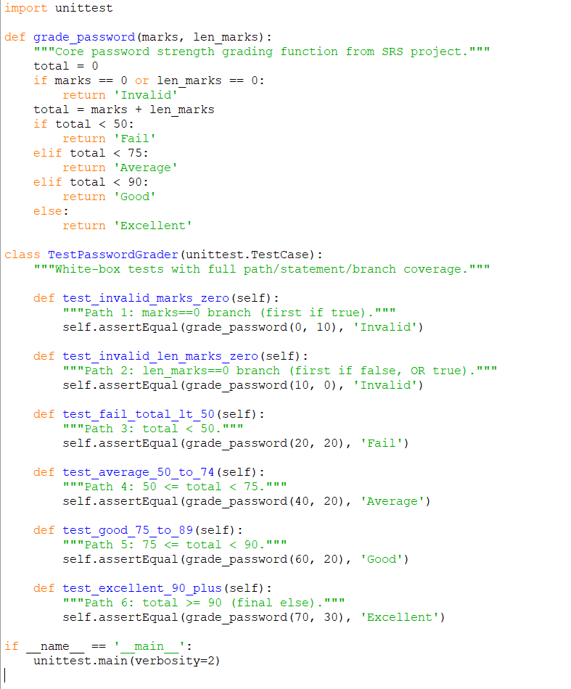
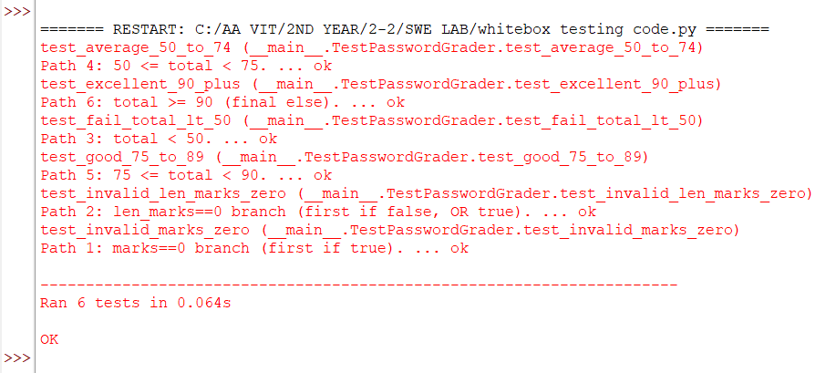

- Flow Graph Notation

- Cyclomatic Complexity

Method 1: Using Regions
The cyclomatic complexity corresponds to the number of closed regions in the flow graph plus the one outer region.
- Number of Inner Regions: 5
- Number of Outer Regions: 1
- Total V(G) = 5 + 1 = 6

Method 2: Using Edges (E) and Nodes (N)
Using the formula V(G) = E - N + 2, where E is the number of edges and N is the number of nodes.
- Number of Nodes (N): 15
- Number of Edges (E): 19
- Calculation: 19 - 15 + 2 = 6

Method 3: Using Predicate Nodes (P)
A predicate node is a node that contains a condition (decision point). Using the formula V(G) = P + 1.
- Predicate Nodes: Node 3, Node 4, Node 8, Node 10, and Node 12.
- Number of Predicate Nodes (P): 5
- Calculation: 5 + 1 = 6

- Independent Program Paths
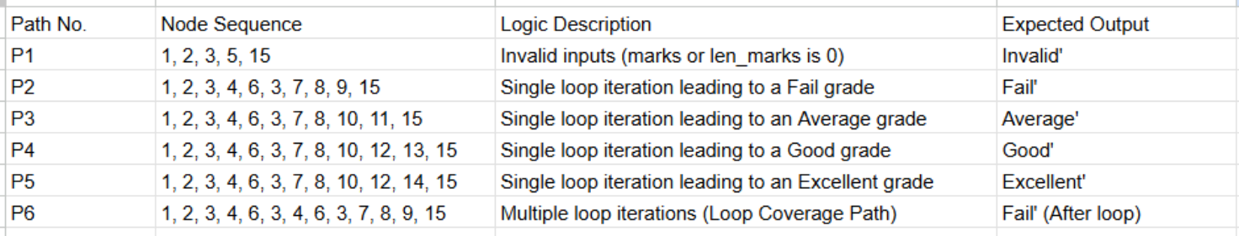

  - Black-Box Testing

Black-box testing validates functional requirements exclusively. Testers remain blind to implementation details. They verify expected outputs match specified inputs across all user scenarios. Equivalence partitioning handles PIN lengths efficiently. Boundary analysis tests exactly five failed attempts. Decision tables validate authentication combinations thoroughly. State transitions confirm smooth workflow progression.
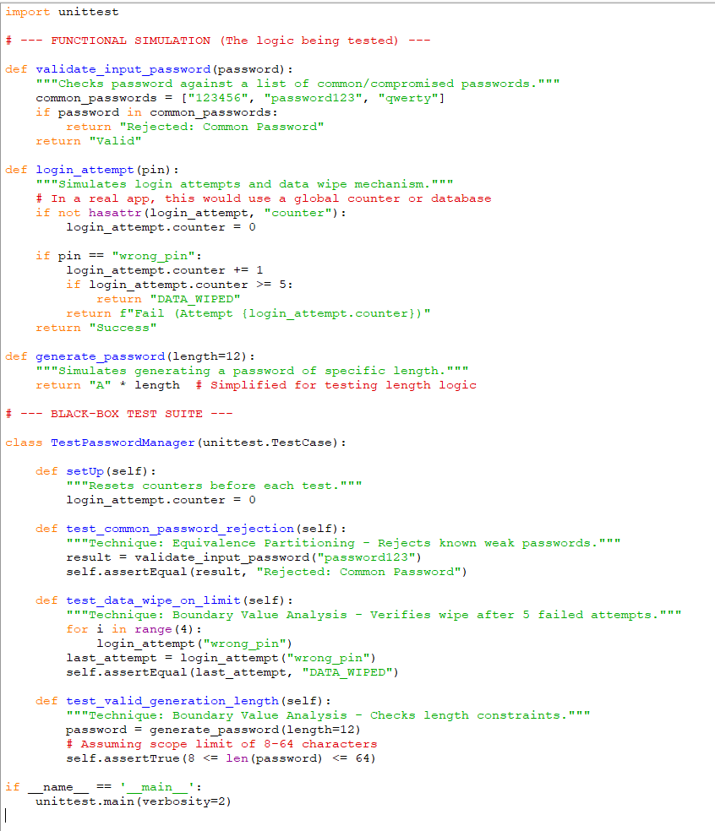
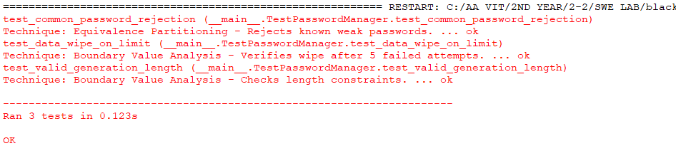

- Boundary Value Analysis

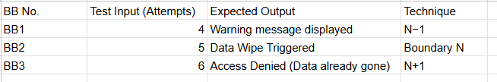

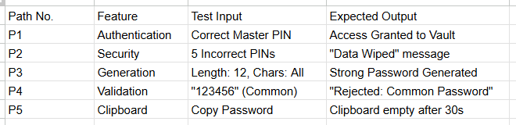

- Component Level Diagram
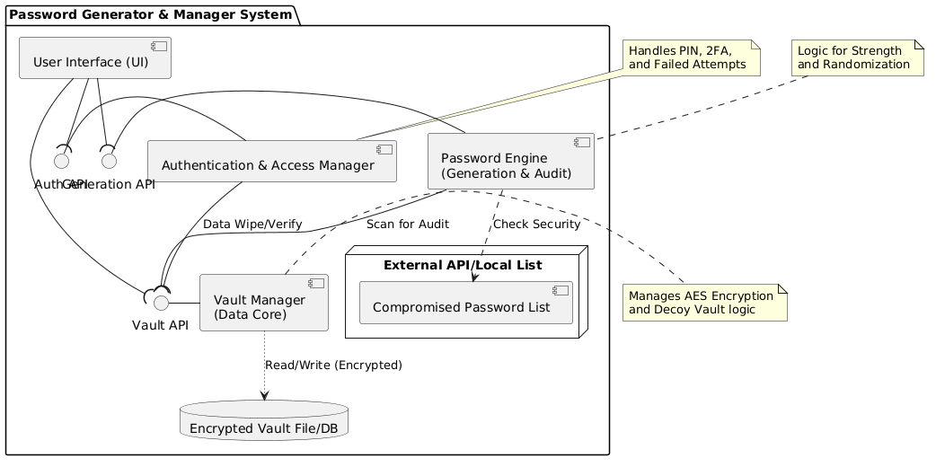
- Deployment Level Design Diagram
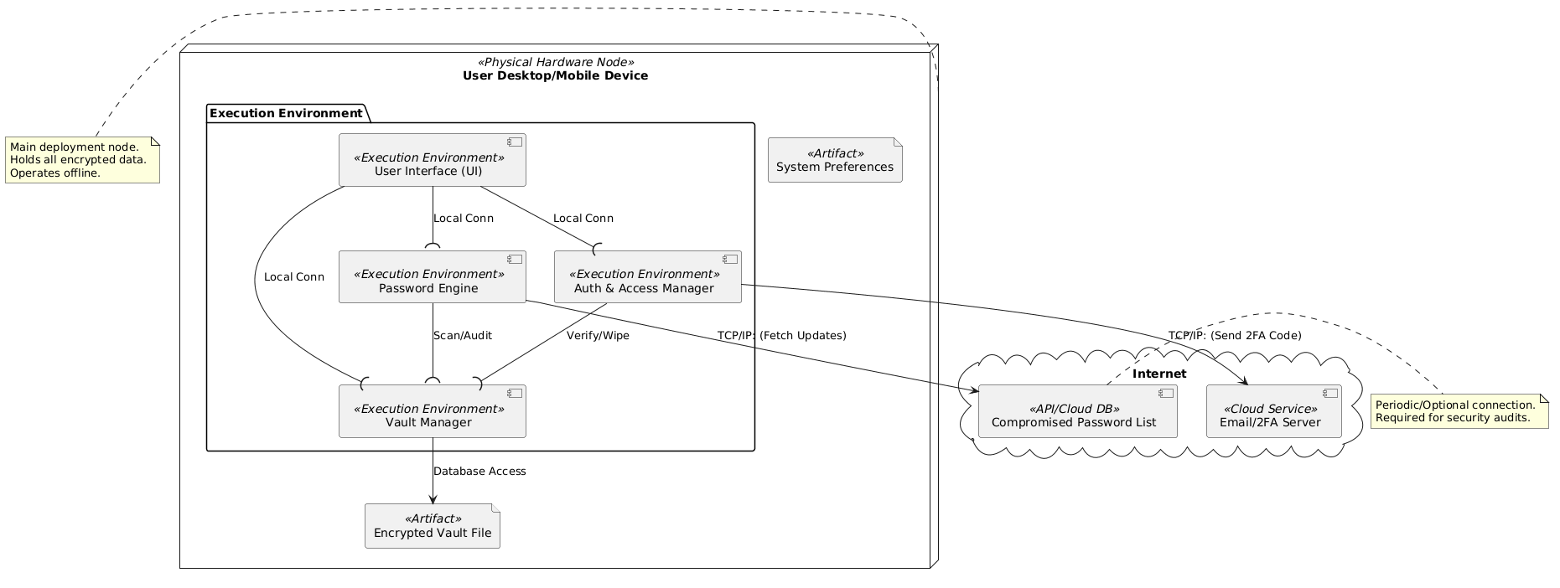

- PROJECT METRICS
This section looks under the hood of our Simple Password Generator and Tracker. Instead of just counting lines of code we use Function Based Metrics to measure the actual work the software does for the user. By quantifying features like how we handle inputs or store data we get a realistic estimate of the effort needed to build and test the system.

  - Metrics for the Analysis Model: Calculating UFP

First we look at the Unadjusted Function Points or UFP. Think of this as the raw size of the application based on its core features. We categorized these into five areas ranging from how users enter data to how the app talks to external services like 2FA.

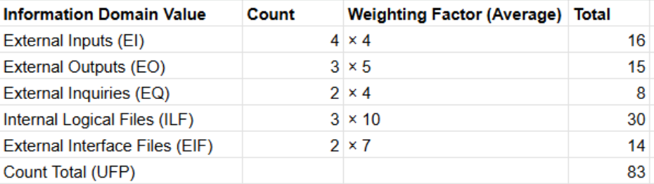

- External Inputs (EI): These are the ways the user gives information to the app such as setting up a master PIN or adding a new account.
- External Outputs (EO): These are the answers the app gives back like the strength indicator or a warning before a data wipe.
- External Inquiries (EQ): This covers quick interactions such as searching for a specific login or viewing a hidden password.
- Internal Logical Files (ILF): This represents the data we manage internally specifically our encrypted credential vault and user settings.
- External Interface Files (EIF): These are the external helpers like the API we use to send 2FA codes or the master list of common passwords we check.

  - Calculating the Complexity Adjustment Factor (CAF)

Not all apps are created equal because some deal with heavy encryption and strict security rules. To account for this we rate 14 different complexity factors on a scale of 0 to 5

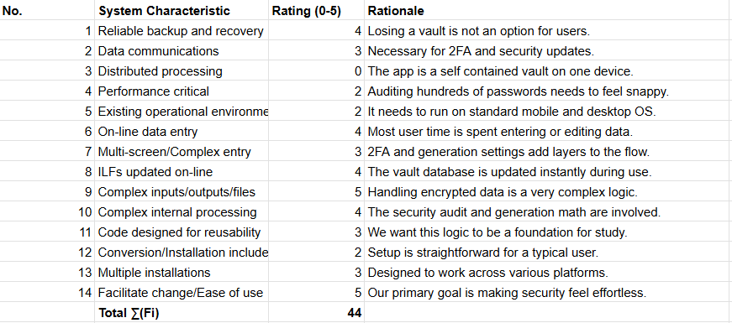

  - Final Function Point (FP) Calculation

Finally we combine our raw size with our complexity score using the standard formula.

Step 1: Find the Complexity Adjustment Factor (CAF): We use a base value of 0.65 and add our scaled complexity score:
CAF = 0.65 + ( 0.01 x 44 ) = 1.09

Step 2: Calculate the Final Function Points (FP) : By multiplying our UFP by the CAF we get the final functional size:
FP = 83 x 1.09 = 90.47

- COCOMO MODEL

  - COCOMO Model
Boehm’s categorizes the projects:
- Organic - If the team size required to develop a software project is small.
- Semi-detached -if team size, experience and knowledge lies in between organic and embedded.
- Embedded -require the highest level of complexity and experience along with large team size.
COCOMO model (Constructive cost model) is a regression based model, proposed by Barry Boehm used for predicting the various parameters associated with development of a project.

There are three types of COCOMO models:
            - Basic COCOMO Model
            - Intermediate COCOMO Model
            - Detailed COCOMO Model

  - Basic COCOMO Model

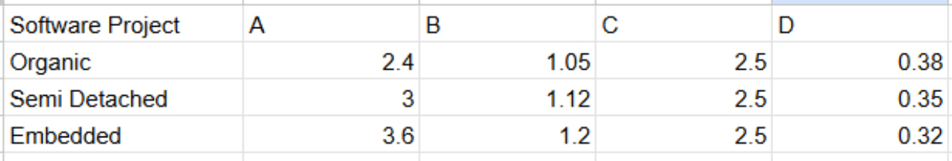

- Estimated size of project:
Based on the final Function Point calculation of 90.47 FP, the estimated size in lines of code for this type of application is approximately 4,523 LOC.
- KLOC = 4.52
- Therefore, it is an Organic mode of project.

- Effort (E) = A * (KLOC) ^ B
= 2.4 * (4.52) ^ {1.05}
=11.72 Person-Month
- Time (T) = C * (Effort) ^ D
= 2.5 * (11.72) ^ {0.38}
= 6.35 Months

  - Intermediate COCOMO Model

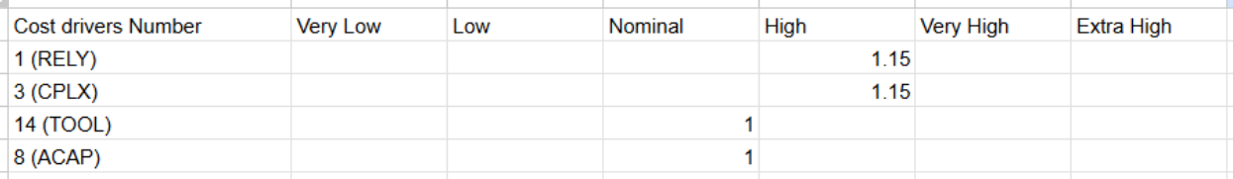

EAF (Product of cost drivers) = 1.32

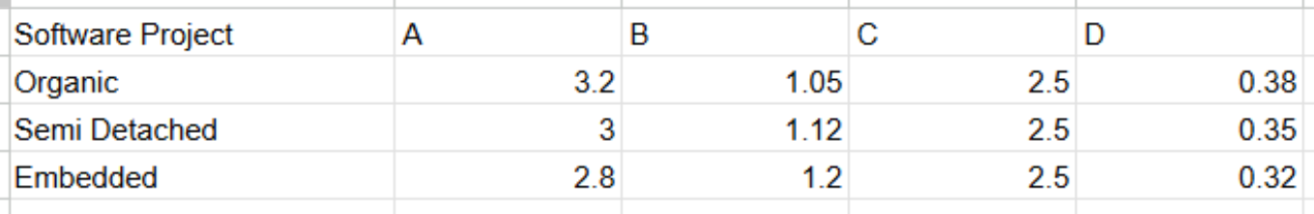

- Effort (E) = (A * (KLOC) ^ B) * EAF
= (3.2 * (4.52) ^ {1.05}) * 1.32
= 20.62 Person-Month
- Time (T) = C * (Effort) ^ D
= 2.5 * (20.62) ^ {0.38}
= 7.88 months
- Persons required = Effort / Time
= 20.62 / 7.88$
= 2.62 (approx. 3 persons)

- ACKNOWLEDGEMENT

I would like to express my sincere gratitude to faculty for their valuable guidance and support throughout the preparation of the Software Requirement Specification (SRS) document for the Online Personalized Shopping System. Their suggestions and encouragement helped us understand the concepts of software engineering and system design more effectively.

